Note: This document is “view only”. Please create a copy of this document and save it to your drive.

**SOP- Updating SN Master Documents While Onboarding Clients - Systems Vault**

**PREREQUISITES**

[SOP- MASTER Client Onboarding- Systems Vault](https://docs.google.com/document/d/1h15rYHmTzGFdfzso_DxqyYtqkFcpNlM8DWo4YLwYBn4/edit?usp=sharing)

[Master: Client Details](https://docs.google.com/spreadsheets/d/1jHG9MEvCmCceeMhdQoOiuUFtzoz0OX240_Fw3Km_i98/edit?usp=sharing)

[Master: Client Retainers/Invoicing](https://docs.google.com/spreadsheets/d/1cM1PaOQvNorHst9dk7LXrNih0990Rc1fXWaWv1UgM5Y/edit?usp=sharing)

[SOP- Creating and Keeping Client Briefs Current - Systems Vault](https://docs.google.com/document/d/1ptPCYC4plL4lOFK4vNKlakm7XWJL-66yrreQxpcTqog/edit?usp=sharing)

**PURPOSE**

To keep our master documents up to date. These are used for things like weekly updates on retainer hours and tasks completed, client briefs, keeping track of important client details, etc.

**POLICY**

These tasks are carried out as part [SOP- MASTER Client Onboarding- Systems Vault](https://docs.google.com/document/d/1h15rYHmTzGFdfzso_DxqyYtqkFcpNlM8DWo4YLwYBn4/edit?usp=sharing)

**PARTY**

Online Business Manager

**PROPERTY**

Online Business Manager

**PROCESS**

Part 1: Update [Master: Client Details](https://docs.google.com/spreadsheets/d/1jHG9MEvCmCceeMhdQoOiuUFtzoz0OX240_Fw3Km_i98/edit?usp=sharing)

Part 2: Update [Master: Client Retainers/Invoicing](https://docs.google.com/spreadsheets/d/1cM1PaOQvNorHst9dk7LXrNih0990Rc1fXWaWv1UgM5Y/edit?usp=sharing)

Part 3: [SOP- Creating and Keeping Client Briefs Current - Systems Vault](https://docs.google.com/document/d/1ptPCYC4plL4lOFK4vNKlakm7XWJL-66yrreQxpcTqog/edit?usp=sharing) (as needed)

**PROCEDURES**

**Part 1: Update** [**Master: Client Details**](https://docs.google.com/spreadsheets/d/1jHG9MEvCmCceeMhdQoOiuUFtzoz0OX240_Fw3Km_i98/edit?usp=sharing)

1. Access the [Master: Client Details](https://docs.google.com/spreadsheets/d/1jHG9MEvCmCceeMhdQoOiuUFtzoz0OX240_Fw3Km_i98/edit?usp=sharing) document and make sure that all of the columns are filled out. If you don’t know the answer to any of the columns right now (ex. If we do their Wordpress/theme updates), make a task for yourself to complete the document when you have answers.
2. Fill out all columns in all three tabs
   1. Client Briefs
   2. Client Deets
   3. Client Birthdays
3. Only create a Teamwork Email Address if the client will be using our Teamwork PM
   1. Navigate to client project
   2. Click on tasks:



* 1. Select ‘Options’ icon > ‘Post tasks via email’

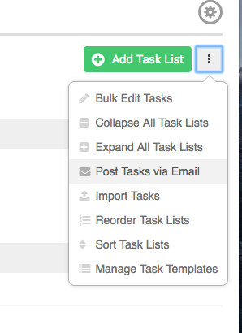

* 1. Update the email address to include the clients name (by default)

1. Indicate Analytics Reporting in the [Master: Client Details](https://docs.google.com/spreadsheets/d/1jHG9MEvCmCceeMhdQoOiuUFtzoz0OX240_Fw3Km_i98/edit?usp=sharing) sheet
   1. Reporting on metrics should start at the end of the first month of work with the client. If you are doing this before then, make a note in the document for the team member who does metrics reporting to note that it shouldn’t be sent to the client until a certain date
2. Indicate Weekly Website Updates reporting in the [Master: Client Details](https://docs.google.com/spreadsheets/d/1jHG9MEvCmCceeMhdQoOiuUFtzoz0OX240_Fw3Km_i98/edit?usp=sharing) sheet

**Part 2: Update** [**Master: Client Retainers/Invoicing**](https://docs.google.com/spreadsheets/d/1cM1PaOQvNorHst9dk7LXrNih0990Rc1fXWaWv1UgM5Y/edit?usp=sharing)

1. Add the client first name and lastname and update the following sections (default)

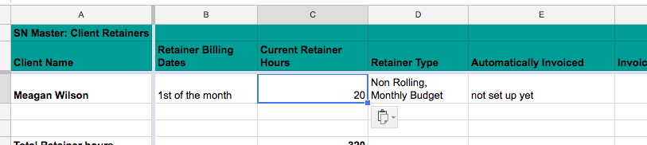

**Part 3:** [**SOP- Creating and Keeping Client Briefs Current - Systems Vault**](https://docs.google.com/document/d/1ptPCYC4plL4lOFK4vNKlakm7XWJL-66yrreQxpcTqog/edit?usp=sharing) **(as needed)**

**Created by:**

**Department:** Delivery

**Date:**

**Revised:**

**Revised by:**